**Abstract:**

Making predictions about the stock market is challenging, since there are many factors that influence how the market behaves. For my project I’m predicting the Istanbul Stock Exchange (ISE) using the data from the UCI machine learning repository. There are several features in the dataset such as a, b, c.., and the primary attribute is the ISE feature, which is used to predict stock values using the machine learning models. The goal of this project is to compare how well two model forecast the ISE index: Long Short-Term Memory (LSTM) and Autoregressive Integrated Moving Average (ARIMA). Finding the model with the highest accuracy while utilizing the least amount of data input is one of the goals. By creating the model architecture, assess the model performance and figure out the best model for short-term stock prediction by studying the relevant literature on predicting stock using LSTM and ARIMA. The understanding of the stock exchange trends and the effectiveness of models in financial forecasting will be enhanced by the result of this study.

**Introduction:**

**Background**

Forecasting the stock market’s future using the past data and other influencing factors is referred as stock market prediction. There are two popular approaches to stock price forecasting. First and foremost is “fundamental analysis”, which can be divided into top-down and bottom-up approaches. Price/earnings (P/E) ratios and other metrics are used in bottom-up analysis to assess a company’s performance, whereas top-down analysis begins with the state of the economy as a whole and forecasts how it will impact specific stocks. The second method is “technical analysis”, which looks for patterns in charts and projects future price movement by analyzing historical price trends. A few investors utilize both approaches: technical analysis indicates the trend’s entry point, while fundamental analysis offers them multiple point of views on a stock. (FIGURE 1)

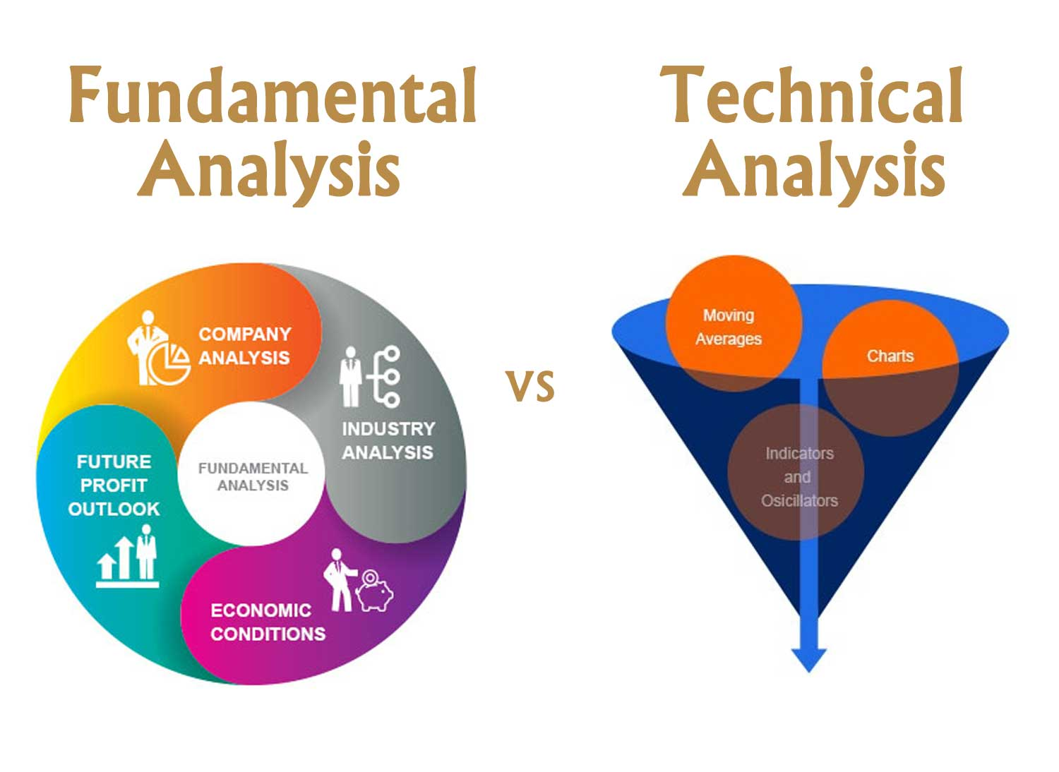

**Figure 1: Fundamental Analysis and Technical Analysis comparison**

The ability to make better decisions and control risk is one of the main advantages that offers the investors, financial analysts, and traders to reduce risk and make smarter judgements. Because of several factors that may impact market behavior in addition to the regular fluctuations in prices, predicting stock market values is a difficult and complex undertaking.

One important financial market that represents Turkeys economy performance and investment opportunities is the Istanbul Stock Exchange (ISE). Both domestic and foreign investors can benefit from understanding and forecasting the ISE attribute. In this study, I made use of the UCI machine learning repository’s dataset “Istanbul Stock Exchange (ISE)”. With so many variables involved in predicting stock values, it is difficult to make predictions values with great accuracy, which is where machine learning comes in important. The applications of machine learning and statistical models in financial forecasting has been developing with an aim of improving the accuracy and confidence of investing predictions.

Features include the value of the Istanbul Stock Exchange (ISE) index, the Standard & Poor’s 500 index (SP), which tracks the performance of 500 large US companies, the German stock market index for 30 major companies (DAX), the London Stock Exchange’s 100 largest companies (FTSE), the Tokyo Stock Exchange’s 225 large companies (NIKKEI), and the Brazilian stock market index (BOVESPA). EU, index that monitors stock performance among EU member nations. Emerging Markets Index (EM), which represents stocks in developing nations. Collectively, these characteristics offer a thorough understanding of the regional (ISE) and worldwide market environments, assisting in the development of a strong predictive and fully understanding the connections between the targeted variable and other financial metrics.

Machine learning research is used to establish how much historical data the model must study to anticipate the stock market. And each pricing attribute is given a weight by the machine learning model. Recurrent neural networks (RNNs) and long short-term memory (LSTMs) are the common machine learning models used to predict time series data, including stock prices, weather forecasts, and housing prices. By assessing how important each factor is of recent versus historical data helps to identify the factors that have the greatest influence on present- or next-day prices.

**Problem Statement**

This study’s main goal is to use the historical financial data to anticipate the Istanbul Stock Exchange (ISE) with accuracy. Choosing the right model for prediction is important because of the complexity of financial markets. Even though they are widely used, traditional time series models like ARIMA might not be able to properly represent complex dependencies on time and non-linear relationships. On the other hand, advanced deep learning models such as LSTM network have shown progress in processing sequential data; however, they require sufficient training data and appropriate tuning. The objective of this research is to evaluate and compare the ISE indices forecasting performance of the LSTM and ARIMA models to identify which model requires less data to provide forecast that are more accurate.

**Justification of the study**

This study is justified by the potential benefits of improving investment forecasting accuracy. Accurate models may enhance financial decision-making, investment strategies and risk minimization. By evaluating the performance of LSTM and ARIMA models, identifying the benefits and drawbacks of each model, this project contributes to the ongoing research in financial projections. The findings will be useful to the investors, financial analysts and researchers who are interested in applying machine learning and statistical models in the financial market. And in cases where data is very limited, understanding which model performs best with less data might be extremely beneficial.

**Research Questions**

The research aims to provide explanation to the following questions:

1. When predicting the stock market with limited amounts of data input, which model LSTM or ARIMA provides the highest accuracy?
2. By studying market movements, daily returns, moving averages and correlations between stocks, how can we forecast future stock behavior?

**Aims and Objectives**

The aim of this research is to find out whether model like LSTM or ARIMA predicts the Istanbul Stock Exchange (ISE) index more accurate. The objective is to:

1. Explain how well the ARIMA and LSTM model predicts the ISE index.
2. Determine which model works best with minimum data input.
3. Describes some efficient financial forecasting techniques.

**Literature Review**

“Stock Predicting based on LSTM and ARIMA”

Qian, H. (2022), in their case study of “Stock Predicting based on LSTM and ARIMA” using LSTM and ARIMA model 95% of the total data for each stock is applied as the training set data, which is used to train the model parameters and rest is used as the test set data. The data used is Google Stock Price from April -2017 to April-2022. The model’s predicted outcomes on the test dataset validates the model’s benefits and drawbacks. To avoid the overfitting, incorporate several dropout layers and six LSTM layers into the LSTM model architecture. The output’s dimensions are 64 units, and the return sequences parameter represent stock. Using LSTM and ARIMA 487 to predict whether to return the entire series or only the last output in the output sequence, with input_shape serving as the shape of the training set. The dense layer with a specified output of one unit will be added, and the drain layer with an output value of 0.2 will be eliminated. Lastly, the model works with a batch size of 32 and can be used for 100 iterations. But the study doesn’t train RNN on the entire observation sequence, instead it uses a batch of small subsequences randomly selected from the training data. According to the prediction findings, the LSTM algorithm outperforms the alternative ARIMA in terms of MSE, MAE and RMSE. When projecting future prices, investors in the capital market may find the findings of this study useful. 97% of the data was collected, which was highly promising for this research project. During the training of the model values of 01.3071 at epoch 74 is the best validation performance. (NO DATASET link).

“Comparison of ARIMA, ANN and LSTM for Stock Price Prediction”

Ma, Q. (2022) examined the three models in this research. Through an analysis of the three model’s underlying assumptions and forecast outcomes, this paper particularly contrasts three models. Although the LSTM model is heavily influenced by the data processing, it is considered to have the best prediction performance in the end. In terms of performance, the ANN model outperforms the ARIMA model. Also, Ma, Q. mentioned it’s possible that the ANN is more responsible for the LSTM model’s performance. Additionally, by strengthening the white noise sequence, ARIMA-GARCH can rise the ARIMA model’s accuracy even further. In comparison with the other two models, the LSTM model adds additional variables to differentiate between abrupt changes and sudden fluctuations in markets. The dataset is “DELL's stock price” from 2010 used to analyze the models in this study.

“Time series forecasting of stock market using ARIMA, LSTM and FB prophet”

Sunki, A., SatyaKumar, C, Surya Narayana, G, S., Koppera, V., & Hakeem, M. (2024) concluded that, time series forecasting in the stock market is a challenging task requiring technical methods and careful research. Though no forecasting technique can accurately predict stock prices, time series forecasting offers helpful insights and helps investors make viable choices. These models incorporate a variety of factors, including trend, seasonality, and autocorrelation, to generate projections. As a result, it can be concluded that the ARIMA model provides a better match to the data than both LSTM and FBProphet models.

Based on these three models, ARIMA has the lowest RMSE (root mean square error) value 7.8919253, suggesting that it has the highest predicted accuracy for this dataset. Followed by LSTM model has the 10.33765 RMSE value and FBProphet 9.11863 also had the lower RMSE value which appears to be the least accurate in predicting the target variable. The dataset used in this paper is “Netflix”

“ARIMA vs LSTM on NASDAQ stock exchange data”

Kobiela, D., Krefta, D., Krol, W., Weichbroth, P. (2022) in their case study of using ARIMA and LSTM, which model works better in terms of the selected input data, parameters and the feature count has been shown in this research paper. Mean Square Error (MSE) and mean absolute percentage error (MAPE) were the relative metrics used to compare the selected models. And in regression problems usually use selected measures. By comparing the selected metrics in various models, the study reveals which model performs better.

The prediction of the stock prices performed over a range of time periods, from one day to nine months. Overall, ARIMA is better at processing single-feature (price) data, and it generally performs better that LSTM, especially over a long period of time. Due to absence of more features, LSTM struggled with learning and only performed better for one-day forecasts. Future study involves adding more features and exploring hybrid models which potentially increase LSTM performance. The study concluded that, for single-feature stock price prediction on “NASDAQ data”, ARIMA is now more successful.

“A Comparative Study of Future Stock Price Prediction Through Artificial Neural Network and ARIMA Modelling”

Varshney, S., & Srivastava, P. (2024) this study compares and calculates the stock price forecasting using ARIMA and ANN. The outcomes showed that the ANN approach to stock price forecasting is more accurate that ARIMA modelling. The NIFTY 50 index closing price from the NSE India served as the source of data for this research. The Levenberg–Marquardt algorithm was used to simulate and train the network. Given the forecast error arising from these two models is rather small, it is evident that they reached nearly forecast performance. These results are comparable to those of Adebiyi et al. (2014) ANN results are predicted more accurately than ARIMA. The ANN model’s predicted line and the NSE index actual values nearly overlap. On the other hand, the ARIMA model’s prediction appears to diverge rather than exactly overlap. Towards the end of the study period, the ARIMA results show rising deviation as it shown a linear pattern that is directed based on the ARIMA model results.

Stock Market Prediction Using LSTM Technique,

<https://www.ijraset.com/research-paper/stock-market-prediction-using-lstm-technique>

Talati, D., Patel, M., & Patel B. (2022) suggest that because LSTM can manage the sequential and nonlinear structure of financial data and the model is good at predicting the stock prices. The author believes that feature selection and data preparation can improve the model’s performance. The author has trained the model on three different datasets such as “Infosys (1996 to 2022), Microsoft (1986 to 2022) and TCS (2002 to 2022)”.

Enhancing Stock Market Prediction Through LSTM Modeling and Analysis, <https://eudl.eu/pdf/10.4108/eai.2-6-2023.2334692>

Huang, W. (2023), concludes that LSTM model can learn from the sequential patterns of stock data and include long term dependencies, as they are quite predictive at predicting the prices of the stock. The study shows that, the proposed model performs much better that earlier model by Xu and Cohen & Ullah and Qasim, with improvements of 35.18% and 5.86% respectively. The model achieves a high accuracy of 86.77% and shows a significant reduction in errors, with a mean squared error (MSE) and root mean squared error (RMSE) much lower than the original models. The model consists of four layers (100, 50, 100 and 30 units) with dropout used to prevent overfitting. These findings demonstrate the LSTM model’s efficiency and significance of social media variables for accurate stock movement forecasting. The author uses the historical stock price data of “Google stocks “from 2014 to 2019.

“Comparison of ARIMA and Artificial Neural Networks Models for Stock Price Prediction”

https://onlinelibrary.wiley.com/doi/full/10.1155/2014/614342

Adebiyi, A. A., Adewumi, A. O., & Ayo, C. K. (2014) in this study the understanding of ARIMA and ANN models for predicting “Dell stock prices” were examined. Based on the minimal forecast errors and close match to actual prices, ARIMA (1,0,0) was found to be the optimal configuration. Additionally, the ANN model with a 10-17-1 architecture demonstrated great accuracy and minimal mistakes. Although both models worked well, test results showed that the ANN model typically produces forecast that were more accurate than those made by the ARIMA model. Though the ANN model performed somewhat better overall, statistical tests revealed little variance between the actual and predicted values for either model.

Whereas the forecasts of the ANN model closely matched the actual values, the ARIMA model had a directional pattern. To increase forecast accuracy even further using new market indexes and recent stock data, future research may investigate hybrid models.

|  |  |  |  |
| --- | --- | --- | --- |
| **Paper** | **Machine-Learning models** | **Datasets** | **Results** |
| Stock Predicting based on LSTM and ARIMA | LSTM, ARIMA | Google Stock price |  |
| Comparison of ARIMA, ANN and LSTM for Stock Price Prediction | LSTM, ARIMA, ANN | DELL's stock price |  |
| Time series forecasting of stock market using ARIMA, LSTM and FB prophet | LSTM, ARIMA, FB prophet | Netflix data |  |
| ARIMA vs LSTM on NASDAQ stock exchange data | LSTM, ARIMA | NASDAQ data |  |
| A Comparative Study of Future Stock Price Prediction Through Artificial Neural Network and ARIMA Modelling | ANN, ARIMA | NSE India data |  |
| Stock Market Prediction Using LSTM Technique | LSTM | Infosys Microsoft & TCS |  |
| Enhancing Stock Market Prediction Through LSTM Modeling and Analysis | LSTM | Google stocks |  |
| Comparison of ARIMA and Artificial Neural Networks Models for Stock Price Prediction | ARIMA, ANN | Dell stock prices |  |
|  |  |  |  |
|  |  |  |  |

**Methodology**

**Overview**

The goal of this project is to use machine learning techniques to predict the Istanbul Stock Exchange. This will be executed in few steps (Figure 2). Collecting and reading the data is the first step, and the comes data preprocessing, to handle the missing values and identify the features from the dataset. And then data is split into training and testing and trained using LSTM and ARIMA models. Subsequently we will test the models, and in the end, we’ll assess model performance by tuning the parameters to see which model forecast the future stocks more accurately.

|  |
| --- |
| * Clean data (missing values, handle outliers). * Normalize data. * Feature Selection * Install “**ucimlrepo”** * Load fetch” unci repo(id=247) * Here Id is Dataset for Uci repo. * Time series (ARIMA) * LSTM (Long Short-Term Memory) * ANN (Artificial Neural Network) * Update Model architecture. * Update parameters to get better accuracy.   **Dataset**: Istanbul Stock Exchange  End   * SVM (Support Vector Machine) * Time series (ARIMA) * LSTM (Long Short-Term Memory) * ANN (Artificial Neural Network) * Random Forest   Predict the model.  Apply model (Test Dataset)  Predict the future stock market.  Optimize model (Fine-tune model)  Optimize model (Fine-tune model)  Define the ML model architecture.  Train the Model &  Validattion  Split data (Train & Test)  Pre-processing Data  Data Collection  Load & Read Data  Start |

* Training
* Testing
* Validation

**Figure 2: Data management plan flow chart**

**Long Short-Term Memory (LSTM):**

Long Short-Term Memory networks are a type of Recurrent Neural Network (RNN) that process sequential data and collect long-term dependencies. “Hochreiter” and “Schmidhuber” created LSTM to address the issues identified by conventional RNN and machine learning methods. When handling time-series data, like stock prices, which are generally non-stationary and show trends and changing circumstances, LSTM prove to be particularly useful.

**Why use LSTM for predicting stock market?**

With the recent breakthroughs that have been happening in data science, it is found that for almost all these sequence prediction problems, long short-Term Memory networks have been observed as the most effective solution (Talati, D., Patel, M., & Patel B. (2022) IV methodology). The basic idea of traditional statistical models such as linear regression and Autoregressive Integrated Moving Average (ARIMA) is that the data is stationary, that its statistical features such as variance and mean don’t change over time.

Because LSTM has feedback connections, as compared to standard neural networks, it can handle complete data sequences as alternative to only handling single data points. In addition to this, it is very good at identifying and forecasting patterns in sequential data, such as speech, text and time series. By extracting important insight from sequential data, LSTM has developed into an effective tool in deep learning and artificial intelligence that has assisted advances across a range of industries.

Stock prices, on the other hand, show seasonality, patterns, and trends despite not being stationary. LSTMs are ideally suited for stock market prediction because they can manage this non-linear correlation within the data.

**LSTM Architecture**

By understanding the LSTM’s architecture, we shall see in the following section how it solves this issue. LSTM functions quite similarly to an RNN cell at a high level, and this is how the LSTM network operates internally. As seen in the diagram below, the LSTM network design is divided into three components, each of which carries out a distinct task.

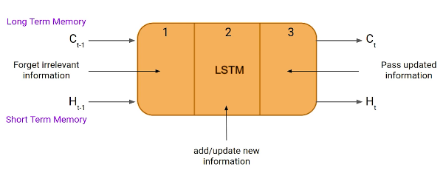

Fig: taken from (https://www.analyticsvidhya.com/blog/2021/03/introduction-to-long-short-term-memory-lstm/)

From the above figure as shown, an LSTM unit consists of three components referred to as gates. They regulate the information that enters and exit the memory cell, also known as the LSTM cell. The first gate is known as the “Forget gate”, where data from the preceding timestamp is either significant and should be remembered, or it can be ignored. Further, the cell attempts to learn new information form the input to this cell at the second gate, which is referred to as the “input gate”. The cell transfers the modified data from the current timestamp to the subsequent timestamp in the final gate, which is called the “output gate”. This LSTM cycle is considered as a single-time step.

An LSTM has a hidden state, just like a basic RNN, where “H(t-1)” is the hidden state of the timestamp that was previously recorded and “Ht” is the hidden state of the timestamp that is currently recorded. Furthermore, the cell state of an LSTM is denoted by “C(t-1)” for the past timestamp and “C(t)” for the present timestamp, respectively. In this case, long-term memory refers to the cell state and short-term memory to the hidden state.

Let’s use the equation to better understanding how these gates function in the LSTM architecture.

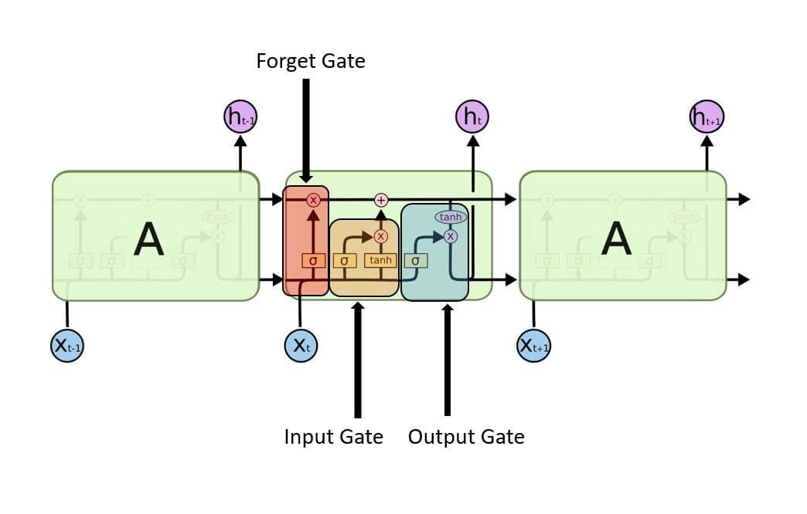

**Figure 3: Long Short-Term Memory Network**

Forget Gate:

In this gate, we must figure out whether to keep or remove the data from the previous time step. Below is the forget gate equation.

FORGET EQUATION

Here, Let’s understand the working of the equation,

Xt: It’s the timestamp’s current input.

Uf: The input’s associated weight.

Ht-1: The previous timestamp’s hidden state

Wf: The weight matrix related to the hidden state.

It then undergoes the use of a sigmoid function. As a result, f and t will become a number 0 and 1. And then the cell state of the earlier timestamp is then multiplied by this f and t.

The input and output gate equation, which is essentially the same as that of the forget gate. Likewise, because of the sigmoid function, its value will also range between 0 and 1. The equations below can be used to feed new data into the input gate and extract the output from the output gate.

Input gate new information:

To handle new information, a sigmoid function is used to modify the existing data, and that’s how the neural networks operate rather than classifying information to be important or not. As a result, the data has been updated completely. LSTM, on the other hand, uses a mechanism to transmit the data known as cell states while executing minimal addition and multiplication changes to the data.

Here is the equation to calculate the new information.

NEW INFO equation

The function of a hidden state at timestamp t-1 and input x at timestamp t now identifies the new information that has to be provided to the cell state. And “tanh” is the activation function in this case. The value of new information will range from -1 to 1 as a result of the “tanh” function. Information is added to the cell state at the current timestamp if the value of Nt is positive, and subtracted from the cell state if it is negative. The cell state at the current timestamp is represented by Ct-1 in this case, and the other values are those we previously calculated.

Output gate:

In this gate we will use Ot and tanh of the updated cell information to compute the current hidden state as shown below.

OUTPUT gate equation

It turns out that the present output and long-term memory (Ct) determine the hidden state. Simply use the “SoftMax” activation on the hidden state Ht if you need to extract the current timestamp output. Finally, the token with the highest score in the output is used to make the prediction.

**Essential elements of LSTM:**

* **Memory Capability**: Because LSTMs can remember information over time, they are perfect for capturing long-term dependencies in sequential data.
* **Gated mechanism**: LSTMs use gates to manage information flow, enabling them to store important data and eliminate unnecessary information.

**Autoregressive Integrated Moving Average (ARIMA)**

Introduction:

A statistical analysis model known as an autoregressive integrated moving average (ARIMA) makes use of time series data to forecast future trends by using historical data or to get a deeper understanding of the data set. One type of regression analysis that evaluates the strength of a single dependent variable in relation to other changing variables is the ARIMA model. Rather than using actual values, the model looks at differences among values in the data set to forecast future movements in securities or the financial markets.

An understanding of an ARIMA model can be gained by describing each of its individual components as follows:

1. Autoregressive (AR): A model that displays a variable that is evolving and evaluates on its own lagged, or prior, results is known as an autoregression model.
2. Integrated (I): To enable the time series to become stationary, the difference between the current and previous values is substituted for the data values, which is represented by integrated.
3. Moving average (MA): Considers a data point’s connection with a residual error by applying a moving average model to observations that are lagged.

**Understanding the parameters of ARIMA:**

With a standard notation, every component in ARIMA operates as a parameter. Standard notations for ARIMA models are with p, d and q, where the parameters are replaced by integers values to denote the type of ARIMA model that is being utilized. One way to define the parameters is as follows:

* AR (P): the model’s autoregressive terms or the number of lag observations.
* I (d): the variation in the observation that are not seasonal, or the number of differencing cycles applied to the raw observations.
* MA (q): the moving average window size, sometimes referred to as the moving average order.

Computer methods and machine learning approaches are used to compute ARIMA model, which are complex and perform best on very large data sets. To make the data stationary in a ARIMA model, they are differenced. A model that demonstrates consistency is one that proves the data stability across time. Since majority of market and economic data exhibits trends, the goal of differentiation is to eliminate any seasonal patterns or trends.

Regression models may be adversely affected by seasonality, which is the occurrence of regular and predictable patterns in data that reoccur over the course of a year. Many calculations made during the process cannot be completed and the desired outcomes can’t be obtained if a trend develops, and stability is not obvious.

To start creating an ARIMA model for a stock, we first download the maximum amount of price data. After determining the data trends, use the autocorrelation to determine the lowest level of differencing (d). A series is considered to be differenced if the “lag-1” correlation is either zero or negative. If the “lag-1” is greater than zero, you might need to vary the series more. Next compare the self-correlation and partial autocorrelation to figure out the order of regression (p) and the order of moving average (q).

**Working of ARIMA model:**

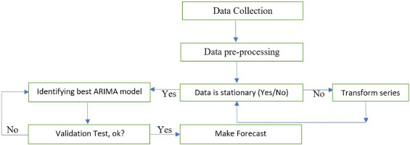

Fig: Methodology to apply the ARIMA model for forecasting,

source: <https://www.sciencedirect.com/science/article/pii/S2666449620300074>

To understanding the working of the ARIMA model in basic terms:

* Collect data: Gather the data that will be studied or used to forecast trends.
* Review data: Ensure that there are no major long-term changes to the data. If so, you may need to make sure that data is stationary through small adjustments.
* Identify model: Examine the data to determine how much, if any, adjustment is necessary and how historical data influences current data. Python libraries can be used for the time series data.
* Check model accuracy: Compare the actual data with the predictions generated by your python ARIMA model to see if the model accurately describes the data.
* Predict future: After the model is well developed, utilize it to project future events based on the prediction of your model.
* Improve model: If the predicted outcomes don’t look great, tune the parameters of the model until the projections looks great.
* And finally, run the model on the testing dataset, verify the predictions and compare the predicted and actual values.

**Overview:**

Using advanced machine learning techniques, namely “Long Short-Term Memory (LSTM) networks” and “ARIMA” model, the main goal of this research is to accurately forecast stock values for the “Istanbul Stock Exchange (ISE)”. To create and assess prediction models, the approach consists of multiple phases, such as feature selection, data-preprocessing, data-collecting, and detailed data analysis. This section describes how the dataset was prepared and analyzed for accurately stock market forecasting, along with the considerations and actions that were involved.

**Data Collection**

The UCI machine learning repository, which offers a large dataset for predicting stock markets research, is the source of the data used in this work. Daily data from several global market indexes, including the ISE index, FTSE, DAX, NIKKEI, BOVESPA and Standard & poor’s (SP), EU, EM, is included in the dataset. Together, these indexes reflect a range of economic situations and offer a solid basis for simulating the movements of the Istanbul Stock Exchange.

Description of the dataset:

The primary target variable is the Istanbul Stock Exchange (ISE) index, which displays the value of an index of stocks and bonds traded there. Furthermore, the dataset contains other attributes that map to other important global indices, including:

* Standard & Poor’s 500 index (SP): It is a key metric for both US stock market and the world economy, since it represents the economic growth of 500 large-cap US corporations.
* DAX: over 30 significant German firms that trade on the “Frankfurt Stock Exchange” are tracked by DAX, which offers market insights throughout Europe.
* FTSE: The FTSE, which tracks the top 100 firms listed on the “London Stock Exchange”, is an essential indicator of the state of the UK economy.
* NIKKEI: Considering the state of the Japanese economy, it consists of 225 business that are listed on the “Tokyo Stock Exchange”.
* BOVESPA: Brazil’s main stock market index, which shows how the country’s economy is doing.
* EU: A composite indicator that reflects the European union’s economic activity.
* EM: The Emerging market index provides a perspective on the state of the developing countries’ economies by representing stocks from these markets.

**Data Preprocessing**

To ensure that the data is clear, consistent, and appropriate for analysis, preprocessing the data is an essential step in getting the dataset ready for modeling. The steps needed to preprocess the data are described in this section.

Handling missing values: Machine learning model performance can be greatly impacted by missing data. Therefore, handling null values, missing data is the first step in preprocessing.

**Scaling and Normalization:**

All numerical features were scaled to fall into a comparable range since any machine learning models, particularly LSTM, ARIMA, works better with normalized data. This enables greater convergence of the model and boosts the learning process.

MinMax Scaling: Features were scaled using the “MinMaxScaler” method. By modifying the values according to the lowest and highest values of each feature, this scaler converts the attributes to a specified range, usually [0,1]. To maintain the strength of each feature’s relationship, scaling was done to each feature separately.

**Data Feature Selection**

Feature engineering is the process of adding new features or changing pre-existing ones to improve the model’s ability to predict the future.

Feature selection: In addition to the ISE index, the main features used for the analysis are the DAX, SP, FTSE, NIKKEI, BOVESPA, EU, and EM. These characteristics were selected considering their potential impact on the target variable and its importance.

Below, find the correlation matrix (heat map) for the data used for the model performance.

Fig: Matrix before feature extraction Fig: Matrix after feature extraction

The first heatmap shows the ISE, SP, DAX, FTSE, NIKKEI, BOVESPA, EU, and EM among its seven indices. With values like 0.87 between DAX and FTSE and 0.95 between EU and FTSE, the heatmap demonstrates the strong correlation between European indices like the FTSE, Eu, and DAX. They have a great deal in common, indicating a strong regional connection. The EU (0.72) and BOVESPA (0.69) have moderate correlations with the Emerging Markets (EM) index, suggesting that there is some global trend alignment. Conversely, the NIKKEI exhibits poor correlations with the majority of indices, particularly with the SP (0.13) and DAX (0.26), indicating that it may be useful for feature extraction diversification since it gathers distinct market data.

ISE, SP, DAX, NIKKEI, and BOVESPA are among the five indices in the second heatmap, which focuses on a smaller number of more specific indexes. Certain correlations hold true in this instance, such as the robust correlation of 0.72 between SP and BOVESPA and the high correlation of 0.69 between DAX and SP. There are fewer market perspectives available without FTSE, EU, and EM.

**Transforming data:**

The data must be transformed into 3D array format, including the features, time steps and samples, to be ready for the LSTM model. Whereas, for ARIMA models data must be stationary, which means that statistical parameters like mean, and variance shouldn’t vary over the course of time. Trends and seasonality are eliminated using transformations like differencing, which subtracts old data points from current ones, to achieve consistency.

**Splitting the dataset:**

The dataset was divided into training and testing data sets in order to assess how well the predictive models performed. Generally, a higher percentage of the data about 70-80% is used for training to feed the model with sufficient knowledge to learn, and the remaining data is used for the testing.

Model Training:

LSTM :

Fig: Model with all features

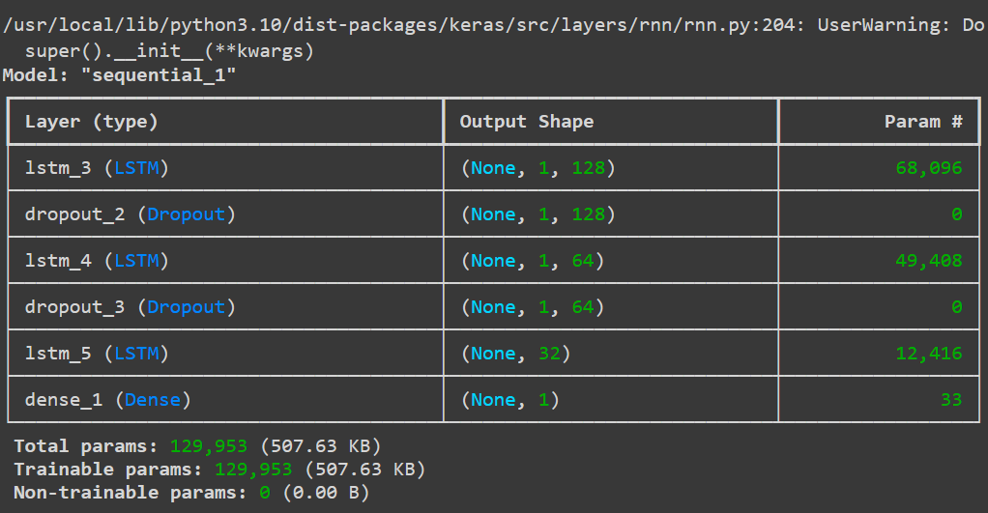

Fig: Model after feature extraction

The figures above describe the creation of the sequential model using keras for sequence-based applications such as time series prediction. The first layer is an LSTM layer with 128 units that processes input sequence and outputs the entire sequence. After that, a dropout layer randomly removes 30% of the units during training to prevent overfitting. A second LSTM layer with 64 units that returns the entire sequence, followed by another dropout layer. When the output of the model is a single value, the third LSTM layer, which has 32 units, is different such that it only returns the last output of the sequence. Since the last layer is dense layer and has only one unit, the model will only produce one continuous value. The model is compiled using the “Adam optimizer” with a learning rate of 0.0003, and the “Mean Squared Error (MSE) as the loss function, followed by “Mean Absolute Error (MAE) as the performance metric. Regression activities involving sequential data, which means time series forecasting, frequently use this structure.

#### explaining

Numerous tests were carried out by adjusting the hyperparameters to determine the ideal model structure after an LSTM model was defined and developed for the purpose of estimating a single constant value. The number of timestep, the number of units in LSTM layers, the dropout rate, and the learning rate were the main hyper-parameters that were adjusted during these studies. The model was trained for 50 epochs in the first experiment using a single timestep, 100 units, a 0.2 dropout rate, and a learning rate of 0.001. The validation mean absolute error (MAE) of 0.0998 showed a decent result for short-term prediction. Later tests found that while the training length got higher, performance was somewhat improved, with a validation MAE of 0.1039, when the timestep and units were increased to 8 and 120, respectively, while the learning rate was lowered to 0.0001. On the other hand, trails with a timestep of 10 and 20 demonstrated that more errors appeared by a combination of a reduced learning rate and additional increases in timestep and units, indicating problems with overfitting and challenging convergence.

The model performed poorly in subsequent trials with smaller unit counts and extremely low learning rates, as demonstrated by larger MAE values and slower training, suggesting that the model had difficulty learning under these circumstances. When the learning rate was slightly increased to 0.00001 and 0.0001, the model performed better, especially when a timestep of 5 and 100 units was used. However, the model did not stabilize and produce consistent results until a learning rate of 0.0003. The model performed exceptionally well, which involved configuring the model with a timestep of 1, a batch size of 16, 128 LSTM units, a dropout rate of 0.3, and a learning rate of 0.0003. The model was trained for 100 epochs, and the results showed that the training process produced a low loss of 0.0100 and a MAE of 0.0784 on the training data. The validation results, on the other hand, were extremely promising, showing a validation loss of 0.0081 and a validation MAE of 0.0726. These figures suggest that the models was well-tuned and capable of producing precise predictions, effectively striking a balance between underfitting and overfitting. Out of all the configurations examined, this one proved to be the most efficient, offering the best performance.

ARIMA:

A code is designed to develop a better time series forecasting model by adding exogenous (independent) variables to the ARIMA technique. A function included in the “pmdarima” package, “auto_arima” iterates over various combinations of the ARIMA components (p, q, d) to automatically determine the optimal ARIMA model parameters (FIGURE). And then, a model is fitted using the “SARIMAX” function from the statsmodels.

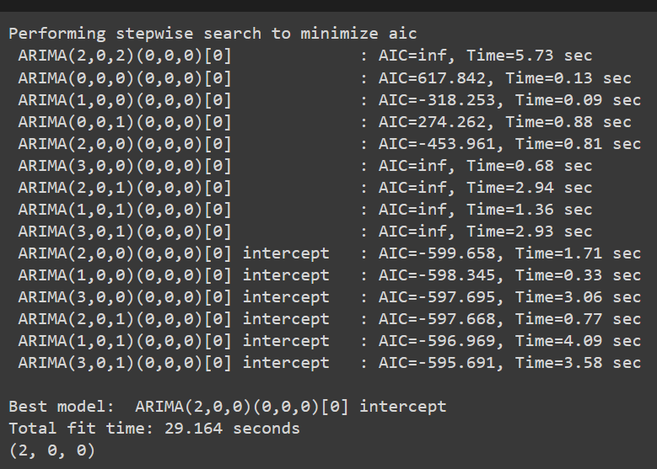

Fig: Auto-arima order Fig: Sarimax model summary

Model summary description:

* Dependent Variable (Dep. Variable): Here ‘y’ is the target variable being forecasted.
* No. Observations: A total of 428 data points used in the model.
* Model: SARIMAX (2, 0, 0), this is the best order identified through auto_arima (figure); this means that (p=2, d=0, q=0) is the ARIMA order.
* Log Likelihood: A model fit metric is 381.715. A better match is indicated by higher values.
* AIC (Akaike information Criterion): Here -749.429 is the AIC value, which is utilized to compare models. A better model is indicated by a lower AIC.
* BIC (Bayesian information Criterion): BIC is -721.015; it penalizes more complex models than the AIC.

HQIC (Hannan-Quinn information Criterion): One other criterion that is comparable to BIC is HQIC: -738.207, provides a medium ground for addressing complexity between AIC and BIC.

A well-fitted and statistically reliable model is produced by the SARIMAX (2, 0, 0) model with four exogenous variables. While the AR component, particularly the second lag, reflects some of the auto-regressive behaviour in the time series, the significant exogenous variable imply that external factors are essential in forecasting the target variable. The model assessment are typically good despite some variance from normality, which makes it a trustworthy forecasting tool for the provided data.

Training curve:

Fig: Training curve with all features Fig: Training curve after feature extraction

**Results And Analysis:**

Several metrics, including (MAE), (MAPE), (MSE), (RMSE), are frequently used to assess the performance of statistical or machine learning models. The model’s prediction reliability and accuracy are revealed by these indicators. The LSTM model exhibits comparatively low error rates prior to feature extraction. The model’s average variation from the actual values is 0.0785 units, as indicated by the MAE of 0.0785. The average percentage variation from the actual data is estimated to be approximately 18% based on the MAPE of 17.97%. And the model is producing predictions that are reasonably near to the actual values, with less squared errors, according to the MSE of 0.01078 and RMSE of 0.1038. It makes sense that RMSE would be somewhat higher than MAE because it assigns greater weight to larger errors.

The performance of the LSTM model marginally declined after feature extraction. The mean absolute error (MAE) went up to 0.0838, suggesting a modest increase. Additionally, the MAPE rose to 19.51%, indicating that the average percentage error is now greater than it was prior to feature extraction at roughly 19.51%. But both the MSE and the RMSE increased to 0.01231 and 0.1109, accordingly, suggesting that the model’s predictions are now less accurate when the extracted features are used. The LSTM model’s performance did not increase with feature extraction. Rather, all error metrics experienced a minor rise, suggesting that the feature extraction process may not have been successful or may have added noise or redundant features that negatively impacted model performance.

On the other hand, the MAE of the ARIMA model is 0.0851, which is higher than that of the two LSTM models. This implies that, prior to feature extraction, ARIMA’s predictions are, on average, less accurate than those of the LSTM model. The MAPE of 18.82% is better than the LSTM model’s after feature extraction but still marginally higher than before feature extraction. Larger prediction error are indicated by the MSE of 0.01301 and RMSE of 0.1141, which are greater than those of the LSTM model prior to the extraction of features.

Reference: